**Software Requirements Specification**

1.Introduction

1.1:Purpose………………………………………………………….2

1.2 Scope …………………………………………………………...2

1.3 Overview………………………………………………………..2

1.4 Definition ……………………………………………………....2

2.Functional Requirement………………………………………………..3

3.NonFunctional Requirement…………………………………………...4

4.Hardware Interface With The Device………………………………….5

5.Usecase and Application Case Diagram……………………………….6

6.Technical Issues………………………………………………………..7

7.Useful Links……………………………………………………………7

**1. Introduction**

The following subsections of the Software Requirements Specifications (SRS) document provides an overview of the entire SRS.

**1.1 Purpose**

The purpose of this document is to present a detailed description of the Android InApp Advertising application. It will explain the purpose and features of the application, the interfaces of the application, what the application will do, the constraints under which it must operate and how the application will react to external stimuli. This document is intended for both developer and user for proposed ad monetization strategy.

**1.2 Scope**

This project is used to serve advertising in android application. In-app advertising is an effective monetization strategy for mobile publishers, in which app developers get paid to serve advertisements within their mobile app. This makes in-app advertising a vital marketing channel for brands and agencies. In-app environment also allows advertisers to reach consumers with pinpoint accuracy.

Scope of this application for developer is to create better user experience. Application improves user in-app engagement and retention via ad monetization strategy. In-app ads are scaled to fit the screen and look better, thereby improving over all engagement.

**1.3 Overview**

This project is used to serve advertising in android application. This is a generic advertising module and utility having capability to show multiple advertisement formats including Interstitials, Rewarded Videos and Banners to the application user. This module uses Ad Networks which connect advertisers and app developers through SDK integration for data analysis.

**1.4 Definition**

1.SRS:Software Requirement Specification

2.SDK:Software Development Kit

3.API:Application Programming Interface

3.UI:User Interface

**2. Functional Requirement**

**Operating Environment Technical Requirements:**

* Android Studio 4.2.2
* Android Software Development Kit (SDK)
* Blue Stack Emulator 5
* Ad SDKs (Iron Source and AdMob) and APIs(Application Programming Interface)
* Java Development Kit (JDK) 8

**Design and Implementation Constraints:**

* This application uses Java, gradle, XML and Android Studio editor for creating the application.
* Blue Stack Emulator 5/Android emulator as an android virtual device

**3. Non Functional Requirement**

1. **Security:**

Sensitive data will be encrypted before being sent over insecure connections like internet. The proper firewalls should be developed to avoid intrusions from the internal or external sources.

1. **Reliability:**

The main pillar of reliability of the system is the backup of the database. Ad Networks continuously maintained and update to reflect the most recent changes.

1. **Availability:**

Ads availability is subject to network conditions and server balancing and frequency of Ad Network.

1. **Maintainability:**

Commercial database is used for maintaining the database and application server takes care of the site. The maintainability can be done efficiently.

1. **Portability:**

The technology should be transferable to different environments easily.

1. **Accessibility:**

Only UI access of the application should be permitted to end users.

1. **Policies:**

The application should adhere to all the legal formalities of the particular ad networks. The applications should maintain security related to sensitive data.

1. **Efficiency:**

The system should provide good throughput and response to multiple users without burdening the system by using appropriate number of servers.

1. **Safety:**

Application should not harm ethical and environmental conditions of the end users devices.

1. **Modularity:**

The application should have user friendly interface. It should be easily updated, modified and reused.

**4.Hardware Interfaces With the Device**

**External Interface Requirements:**

UI:

* All the users will see the same page when they enter in this android mobile application.
* This page shows the users a simple UI with various buttons having capability to show different ad formats.

Hardware Interfaces:

* The module will use the standard hardware and data communication resource
* General network connection at the ad network server and internet connection.

Application Interfaces:

Mobile Operating System**:** Android 6 and above

Communications Interfaces:

* This system uses communication resources as ad networks which connect advertisers and app developers In order to access the ad network, app developers must integrate an [SDK](https://www.ironsrc.com/glossary/sdk/).
* This application will communicate with the module that holds all the APIs information. Module then handles the callbacks along with data from ad network server.

**5.Data Flow Diagrams:**

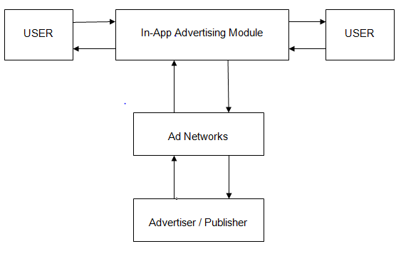

**Figure 1. Data Flow Diagram**

**6. Technical Issues**

* Ad Server fill rate may affect the ad outputs.
* Internet Connection is mandatory

**7.Useful Links :**

1. <https://developers.is.com/ironsource-mobile/android/android-sdk/>

2. <https://developers.google.com/admob/android/quick-start>/

3. <https://developer.android.com/training/basics/firstapp>